**Session Lab 3-10-2023 :**

Container:

<body>

<div class="container m-auto p-5">

Lorem ipsum dolor, sit amet consectetur adipisicing elit. Non, id? Veritatis, rem alias? Repudiandae, unde culpa sapiente aliquid eveniet eum?

</div>

</body>

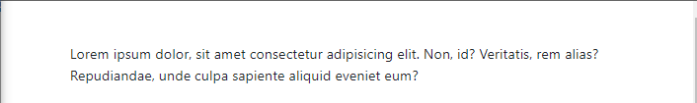

Background Color:

<body>

<div class="container m-auto p-5">

<div class="container bg-primary pt-5"></div>

<div class="container bg-secondary pt-5"></div>

<div class="container bg-info pt-5"></div>

<div class="container bg-dark pt-5"></div>

<div class="container bg-light pt-5"></div>

<div class="container bg-warning pt-5"></div>

<div class="container bg-success pt-5"></div>

<div class="container bg-danger pt-5"></div>

</div>

</body>

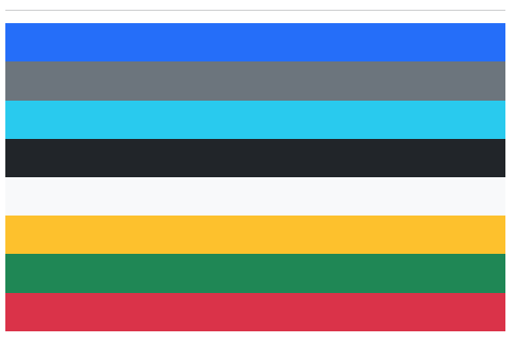

Responsive container

<body>

<h3>responsive container</h3>

<div class="container-sm border p-5"></div>

<div class="container-md border p-5"></div>

<div class="container-lg border p-5"></div>

<div class="container-xl border p-5"></div>

<div class="container-xxl border p-5"></div>

</body>

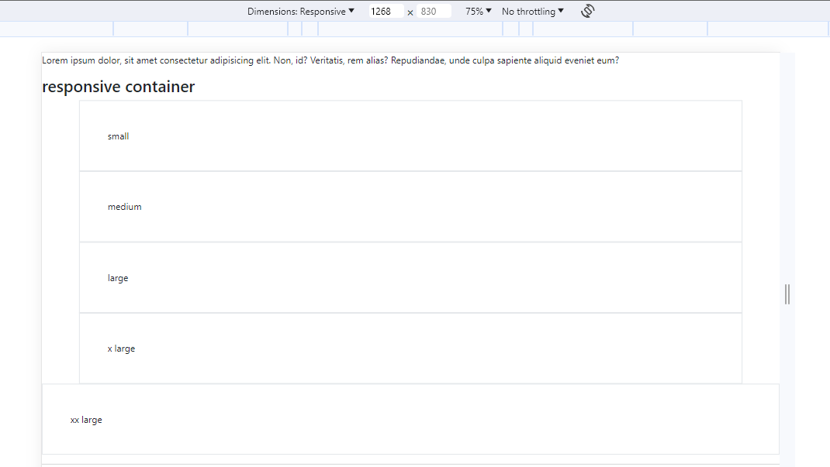

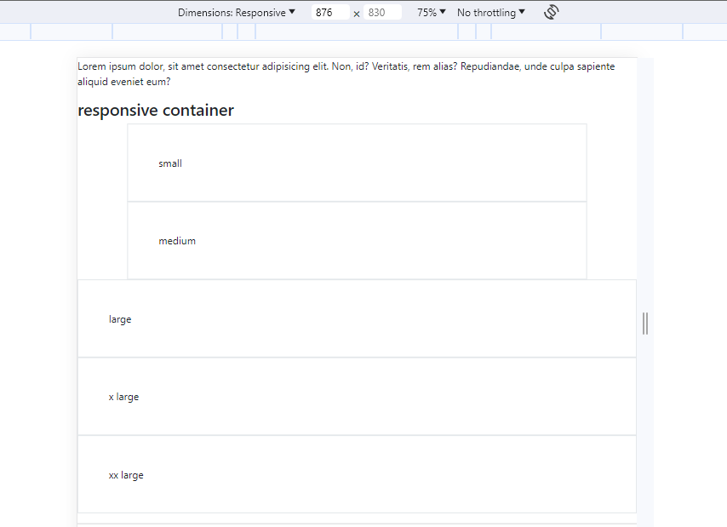

Grid Layout:

<body>

<div class="row border">

<div class="col">column1</div>

<div class="col">column2</div>

<div class="col">column3</div>

</div>

<div class="row border bg-warning">

<div class="col">column1</div>

<div class="col">column2</div>

<div class="col">column3</div>

<div class="col">column4</div>

<div class="col">column5</div>

</div>

<div class="row border bg-success">

<div class="col-sm-4">column1</div>

<div class="col-sm-8">column2</div>

</div>

</body>

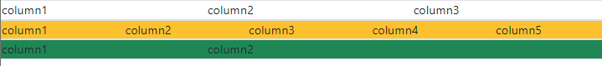

Text-Colors:

<body>

<h2>Text Colors</h2>

<p class="text-primary">text-primary</p>

<p class="text-secondary">text-secondary</p>

<p class="text-info">text-info</p>

<p class="text-warning">text-warning</p>

<p class="text-success">text-success</p>

<p class="text-dark">text-dark</p>

<p class="text-light bg-dark">text-light</p>

<p class="text-danger">text-danger</p>

<p class="text-white bg-dark">text-light</p>

</body>

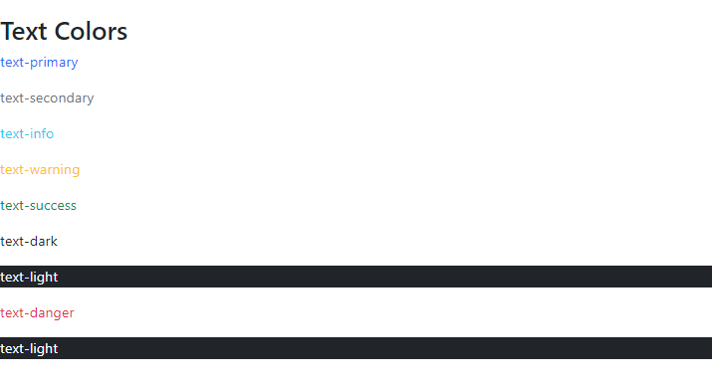

Responsive Table:

<body>

<div class="container p-5">

<table class="table table-bordered table-striped table-dark">

<tr>

<th>Name</th>

<th>Roll No</th>

<th>Subject</th>

</tr>

<tr>

<td>Karan</td>

<td>33</td>

<td>Web Technology</td>

</tr>

<tr>

<td>Darshan</td>

<td>32</td>

<td>DBMS</td>

</tr>

<tr>

<td>Falguni</td>

<td>34</td>

<td>Python</td>

</tr>

<tr>

<td>Karan</td>

<td>33</td>

<td>Web Technology</td>

</tr>

<tr>

<td>Darshan</td>

<td>32</td>

<td>DBMS</td>

</tr>

<tr>

<td>Falguni</td>

<td>34</td>

<td>Python</td>

</tr>

</table>

</div>

</body>

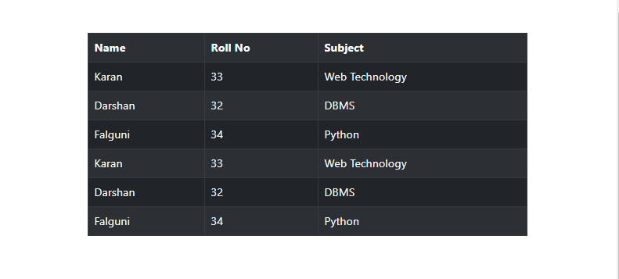

Image

<body>

<div class="container p-5">

<img src="./Assets/JavaScript-logo.png" alt="" class="rounded" />

<img src="./Assets/JavaScript-logo.png" alt="" class="rounded-circle" />

<img src="./Assets/JavaScript-logo.png" alt="" class="img-thumbnail" />

</div>

</body>

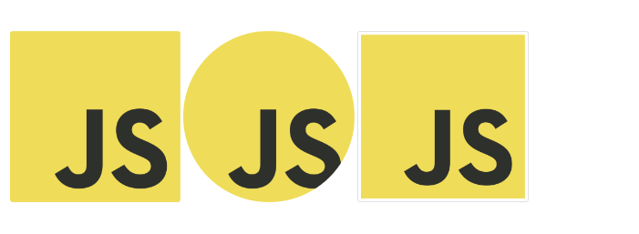

<body>

<div class="container p-5">

<img

src="./Assets/JavaScript-logo.png" alt="" class="rounded-float-start"/>

<img

src="./Assets/JavaScript-logo.png" alt="" class="rounded-float-end" />

</div>

</body>



<body>

<div class="container p-5">

<img src="./Assets/JavaScript-logo.png"alt="" class="d-block"/>

</div>

</body>



Alert

<body>

<div class="container p-5">

<!-- <div class="alert">Alert !</div> -->

<div class="alert alert-primary alert-dismissible">

Alert! this will get close on X click

<button type="button" class="btn-close" data-bs-dismiss="alert"></button>

</div>

<div class="alert alert-secondary alert-dismissible">

Alert! this will get close on X click

<button type="button" class="btn-close" data-bs-dismiss="alert"></button>

</div>

<div class="alert alert-warning alert-dismissible">

Alert! this will get close on X click

<button type="button" class="btn-close" data-bs-dismiss="alert"></button>

</div>

<div class="alert alert-success alert-dismissible">

Alert! this will get close on X click

<button type="button" class="btn-close" data-bs-dismiss="alert"></button>

</div>

<div class="alert alert-danger alert-dismissible">

Alert! this will get close on X click

<button type="button" class="btn-close" data-bs-dismiss="alert"></button>

</div>

</div>

</body>

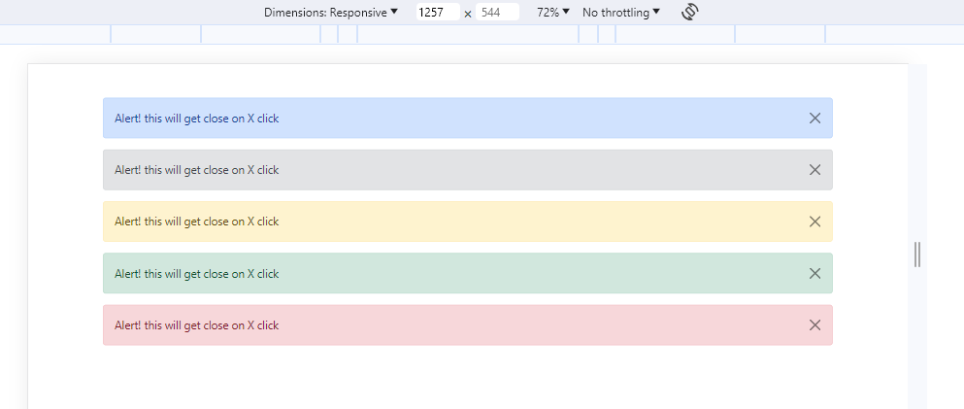

Button

<body>

<div class="container pt-5">

<button type="button" class="btn btn-primary">Primary</button>

<button type="button" class="btn btn-secondary">Secondary</button>

<button type="button" class="btn btn-success">Success</button>

<button type="button" class="btn btn-danger">Danger</button>

<button type="button" class="btn btn-warning">Warning</button>

<button type="button" class="btn btn-info">Info</button>

<button type="button" class="btn btn-light">Light</button>

<button type="button" class="btn btn-dark">Dark</button>

<button type="button" class="btn btn-link">Link</button>

</div>

<div class="container pt-5">

<button type="button" class="btn btn-outline-primary">Primary</button>

<button type="button" class="btn btn-outline-secondary">Secondary</button>

<button type="button" class="btn btn-outline-success">Success</button>

<button type="button" class="btn btn-outline-danger">Danger</button>

<button type="button" class="btn btn-outline-warning">Warning</button>

<button type="button" class="btn btn-outline-info">Info</button>

<button type="button" class="btn btn-outline-light">Light</button>

<button type="button" class="btn btn-outline-dark">Dark</button>

<button type="button" class="btn btn-outline-link">Link</button>

</div>

</body>

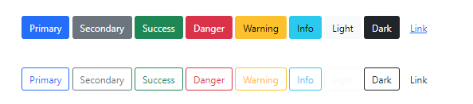

<body>

<div class="container pt-5">

<button type="button" class="btn btn-primary btn-sm">Small button</button>

<button type="button" class="btn btn-primary btn-lg">Large button</button>

<button type="button" class="btn btn-warning">Default</button>

</div>

<div class="d-grid pt-5">

<button type="button" class="btn btn-dark btn-block">full width button</button>

</div>

</body>

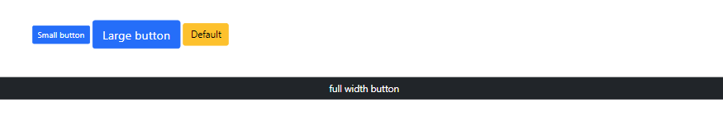

<body>

<div class="btn-group">

<button type="button" class="btn btn-warning">warmin</button>

<button type="button" class="btn btn-info">info</button>

<button type="button" class="btn btn-dark">dark</button>

</div>

<div class="btn-group-vertical">

<button type="button" class="btn btn-warning">warmin</button>

<button type="button" class="btn btn-info">info</button>

<button type="button" class="btn btn-dark">dark</button>

</div>

</body>

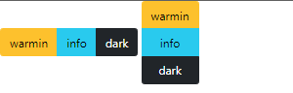

<body>

<h2>Bootstrap List</h2>

<div class="container">

<ul class="list-group">

<li class="list-group-item">Web Technology</li>

<li class="list-group-item">DBMS</li>

<li class="list-group-item">Python</li>

</ul>

</div>

</body>

